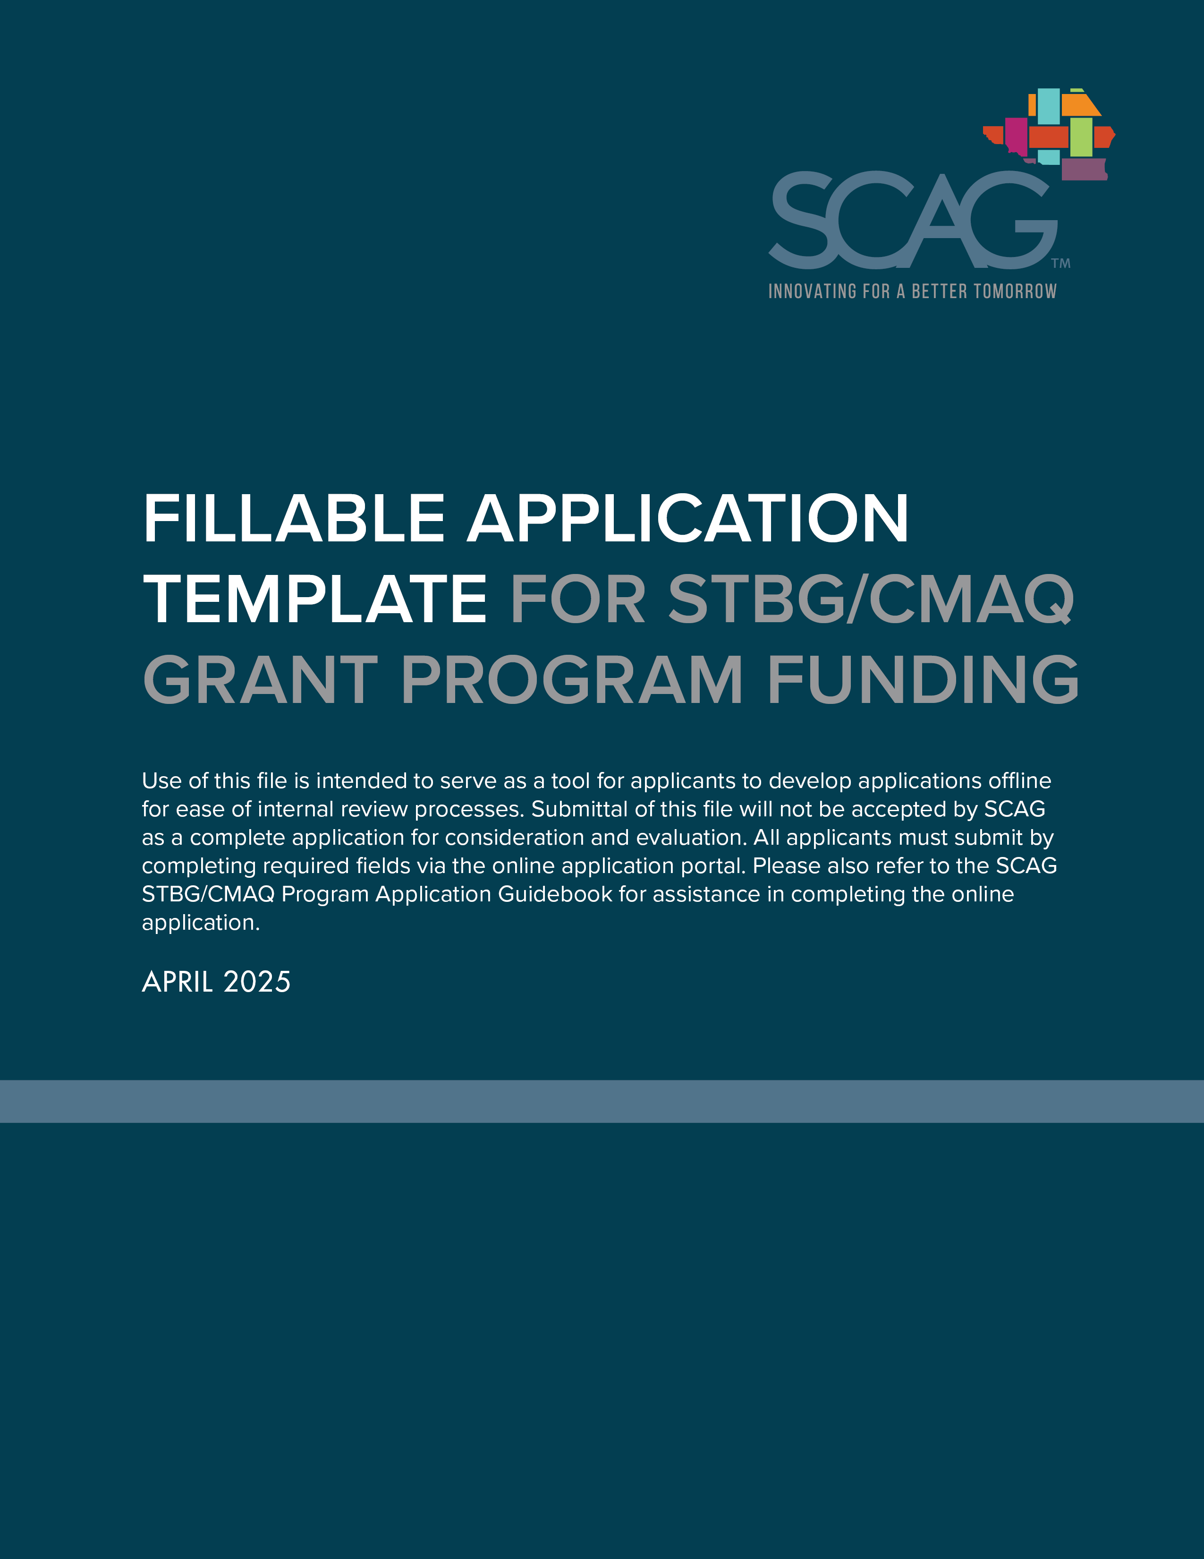

Table of Contents

Overview i

NOTICE: PLEASE READ CAREFULLY 1

Programming Tab 2

Project Information 2

Project Description/Scope and Location 3

Programming Information 4

Additional Funding Information 4

Toll Credit Information 4

Ineligible Costs 4

Cost Increases 5

Project Schedule and Readiness 5

Environmental Document Detail 5

Project Readiness and Deliverability Questions 5

Air Quality Improvements for CMAQ Eligible Projects Only (Part 1) 6

Change Reason Details 6

ID’s/Contacts Tab 7

Attachments Tab 8

Project Questions Tab 9

Regional Priorities 9

Federal Performance Management Areas 9

Community Economic Development Benefits 14

Air Quality Improvements and Cost Effectiveness for CMAQ Eligible Projects Only (Part 2) 16

County Transportation Commission Supplemental Questions 16

General Certification and Assurances 16

# Overview

Projects selected for nomination must be submitted through the **online application** to be considered by the Southern California Association of Governments (SCAG) for Surface Transportation Block Grant Program and/or Congestion Mitigation and Air Quality Improvement Program funding.

The program guidelines and Application Guidebook are available on the SCAG [STBG/CMAQ website](https://scag.ca.gov/surface-transportation-block-grant-program-congestion-mitigation-and-air-quality-improvement-program).

Submissions are due through the [**online application**](https://portal.scag.ecointeractive.com/) by 5 p.m. on **May 16, 2025.**

Required fields are indicated with an asterisk (*).

## NOTICE: PLEASE READ CAREFULLY

**Use of this file is intended to serve as a tool for applicants to develop applications offline for ease of internal review processes.**

**SCAG will not accept submittal of this file as a complete application for consideration and evaluation. All applicants must submit by completing required fields via the online application portal at** [**https://portal.scag.ecointeractive.com/**](https://portal.scag.ecointeractive.com/)

**Please also refer to the SCAG STBG/CMAQ Program Application Guidebook for assistance in completing the online application.**

# Programming Tab

## Project Information

|  |  |
| --- | --- |
| **Field** | **Description** |
| **Project Title\*** | Click or tap here to enter text. |
| **Project Description\*** | Click or tap here to enter text. |
| **Project Type\*** | Click or tap here to enter text. |
| **Lead Nominating/ Implementing Agency\*** | Click or tap here to enter text. |
| **County\*** | Click or tap here to enter text. |
| **Implementing Agency  Mailing Address\*** | Click or tap here to enter text. |
| **Primary Contact Name\*** | Click or tap here to enter text. |
| **Primary Contact Title\*** | Click or tap here to enter text. |
| **Primary Contact Email\*** | Click or tap here to enter text. |
| **Primary Contact  Phone Number\*** | Click or tap here to enter text. |
| **Alternate Contact Name** | Click or tap here to enter text. |
| **Alternate Contact Title** | Click or tap here to enter text. |
| **Alternate Contact Email** | Click or tap here to enter text. |
| **Alternate Contact  Phone Number** | Click or tap here to enter text. |
| **Phase(s) of Work that request would support**  *(PA&ED, PS&E, ROW, CON)\** | Click or tap here to enter text. |
| **Total Funding Request\*** | Click or tap here to enter text. |
| **Implementing Agency Caltrans Master Agreement Number**  *(N/A If no master agreement  is currently in place)\** | Click or tap here to enter text. |
| **PA&ED**- Project Approval and Environmental Documents **PS&E**- Plans, Specifications and Estimates  **ROW**- Right of Way **CON**- Construction | |

## Project Description/Scope and Location

### Scope and location

Please describe the existing conditions, purpose and need of the project and concise scope of work. Please include the location of the proposed project including project limits, cross-streets, or other indicators of location.* (2,000-character limit)

**Type Response Here.**

### Other Location Indicators

|  |  |
| --- | --- |
| **Field** | **Description** |
| **City Council District** | Click or tap here to enter text. |
| **Sub-Region or Council  of Governments** | Click or tap here to enter text. |
| **Air Basin\*** | Click or tap here to enter text. |
| **State Assembly Districts\*** | Click or tap here to enter text. |
| **State Senate Districts\*** | Click or tap here to enter text. |
| **U.S. Congressional Districts\*** | Click or tap here to enter text. |

### Functional Classification of Roadway Location Information

|  |  |
| --- | --- |
| **Indicate System** | **Indicate Functional Classification** |
| Click or tap here to enter text. | Click or tap here to enter text. |

## Programming Information

Please summarize funding information into the table below.*

| **Federal  Fiscal Year** | **Fund Type1** | **Preliminary Engineering (PE) PA&ED** | **PE – PS&E** | **ROW** | **CON** | **TOTAL** |
| --- | --- | --- | --- | --- | --- | --- |
| **(In dollars, $000’s)** | | | | | | |
| Enter text | Enter text | Enter amount | Enter amount | Enter amount | Enter amount | Calculate total |
| Enter text | Enter text | Enter amount | Enter amount | Enter amount | Enter amount | Calculate total |
| Enter text | Enter text | Enter amount | Enter amount | Enter amount | Enter amount | Calculate total |
| Enter text | Enter text | Enter amount | Enter amount | Enter amount | Enter amount | Calculate total |
| Enter text | Enter text | Enter amount | Enter amount | Enter amount | Enter amount | Calculate total |
| 1 - Available Fund Types include: Currently Programmed CMAQ, Currently Programmed STBG, New Request CMAQ, New Request STBG, Other Federal, State, Local, or Remaining Funding Need  **PA&ED**- Project Approval and Environmental Documents **PS&E**- Plans, Specifications and Estimates  **ROW**- Right of Way **CON**- Construction | | | | | | |

## Additional Funding Information

Please use this space to share any additional funding information about your funding plan. If the project has an existing Project Programming Request (PPR) or FTIP sheet, you may provide it as an attachment in the Attachments tab.

**Type Response Here.**

## Toll Credit Information

Is the project utilizing toll credits?*

**Indicate Yes/No**

If yes, indicate Toll Credit Amount.

**Type Response Here.**

## Ineligible Costs

Please indicate if there are known STBG or CMAQ ineligible costs included in the scope of work for the proposed project.*

**Indicate STBG, CMAQ, or N/A**

Please provide any supplemental information as needed (For example, if CMAQ ineligible costs are still STBG eligible, any ineligible components that are not included in the funding request, etc.)

**Type Response Here.**

## Cost Increases

Describe the project sponsor’s ability to address any cost increases outside of this program*. (2,000-character limit)

**Type Response Here.**

## Project Schedule and Readiness

|  |  |  |
| --- | --- | --- |
| **Milestone** | **Start Date** | **Completion Date** |
| **Planning** | Click or tap to enter a date. | Click or tap to enter a date. |
| **Preliminary Engineering (PE) PA&ED** | Click or tap to enter a date. | Click or tap to enter a date. |
| **Preliminary Engineering PS&E** | Click or tap to enter a date. | Click or tap to enter a date. |
| **ROW Phase** | Click or tap to enter a date. | Click or tap to enter a date. |
| **CON Phase** | Click or tap to enter a date. | Click or tap to enter a date. |

## Environmental Document Detail

*National Environmental Policy Act (NEPA)* Environmental Document Type

**Indicate Environmental Document Type**

Environmental Document Type Recorded Date (Actual or Expected)

**Indicate Date**

*Joint California Environmental Quality Act (CEQA)/NEPA* Environmental Document Type

**Indicate Environmental Document Type**

Environmental Document Type Recorded Date (Actual or Expected)

**Indicate Date**

## Project Readiness and Deliverability Questions

Is the project already federalized? If yes, please provide the existing federal project number in the project ID tab.* (2,000-character limit)

**Type Response Here.**

Does the project have a valid right-of-way certification?* (2,000-character limit)

**Type Response Here.**

Identify any known risks to the project schedule and how the project sponsor will mitigate and respond to those risks. Examples of schedule risks include complicated utility relocations, land acquisition needs, and rail company coordination.* (2,000-character limit)

**Type Response Here.**

How is the project being coordinated with impacted or stakeholder agencies (Caltrans, Transit Operators, utilities, railroads, adjacent cities, other state and federal agencies, etc.)?* (2,000-character limit)

**Type Response Here.**

## Air Quality Improvements for CMAQ Eligible Projects Only (Part 1)

| **Project Component** | **VOC**  **(kg/day)** | **CO**  **(kg/day)** | **NOx**  **(kg/day)** | **PM10**  **(kg/day)** | **PM2.5**  **(kg/day)** | **TOTAL**  **(kg/day)** |
| --- | --- | --- | --- | --- | --- | --- |
| Component Description | kg/day | kg/day | kg/day | kg/day | kg/day | Total kg/day |
| Component Description | kg/day | kg/day | kg/day | kg/day | kg/day | Total kg/day |
| Component Description | kg/day | kg/day | kg/day | kg/day | kg/day | Total kg/day |
| Component Description | kg/day | kg/day | kg/day | kg/day | kg/day | Total kg/day |
| **TOTAL** | Total VOC | Total CO | Total NOx | Total PM10 | Total PM2.5 |  |
| **VOC**- Volatile Organic Compounds  **CO**- Carbon Monoxide  **NOx**- Oxides of Nitrogen  **PM10**- Particulate Matter with a diameter of 10 microns or less  **PM2.5**- Particulate Matter with a diameter of 2.5 microns or less | | | | | | |

## Change Reason Details

Please select one of the following:*

**Please indicate New Project, Project Changed*, Project Completed, or Project Removed**

If “**Project Changed**” is selected, select change reason detail:

**Cost increase**

**Existing project for consideration**

**Other: click to explain**

Enter a narrative description of the changes that will be made in this project revision*.

**Type Response Here.**

# ID’s/Contacts Tab

Existing Regional Transportation Plan (RTP) ID

**Type Response Here.**

Existing Federal Transportation Improvement Program (FTIP) ID

**Type Response Here.**

Existing Federal Project ID

**Type Response Here.**

# Attachments Tab

This Tab will allow for attachments to be uploaded as needed.

# Project Questions Tab

## Regional Priorities

If the proposed project has been identified as part of one of the Tier 2 Regional Priorities Program Categories, please indicate and describe if there is an existing systems approach in place to manage these needs. Examples may include: a transportation related natural lands preservation plan (including for wildlife crossings), a pavement management plan or program, a complete streets plan or policies. Please include a link to access any referenced documents.

**Type Response Here.**

## Federal Performance Management Areas

Select all that apply:*

**PM1 – Transportation System Safety**

**PM2 – National Highway System (NHS) Pavement and Bridge Condition**

**PM3 – NHS Performance**

**PM3 – Freight Movement**

**PM3 – CMAQ Program**

**Transit Asset Management**

**Transit System Safety**

### PM1 – Transportation System Safety

#### Level of Impact*

**Indicate High, Medium, Low, or N/A.**

#### General Responses

Does the proposed project implement one or more of the proven FHWA Safety Countermeasure?

Resource: [FHWA Proven Safety Countermeasures](https://highways.dot.gov/safety/proven-safety-countermeasures)

**Type Response Here.**

#### Project Specific Responses

Please describe trends in fatalities or serious injuries that have occurred in the project area in the last five years (in project area or parallel comparable facility if applicable)? Please describe how collision factors were considered in the development of the proposed project.

Resource: [UC Berkeley Transportation Injury Mapping System](https://tims.berkeley.edu/)

**Type Response Here.**

### PM2 – National Highway System (NHS) Pavement and Bridge Condition

#### Level of Impact*

**Indicate High, Medium, Low, or N/A.**

#### General Responses

For projects that include pavement improvements, what is the average PCI category of the City that the project is located in?

Resource:

[2022 Statewide Local Streets and Roads Needs Assessment Report](https://savecaliforniastreets.org/wp-content/uploads/2023/05/Statewide-Needs-2022-FINAL.pdf)

[PCI Maps by County](https://savecaliforniastreets.org/executive-summary/pci-maps-by-county/)

**Click to select one of the following:**

For projects that include bridge rehabilitation, what is the percent of “poor” bridges in the county that the project is located in?

Resource:

[2020 Local Bridge Needs Assessment Report – Figure 3.2](https://www.savecaliforniastreets.org/wp-content/uploads/2021/09/California-Local-Bridge-Needs-Assessment-Report-2020-Final-090121.pdf)

**Click to select one of the following:**

#### Project Specific Responses

For projects that include bridge rehabilitation, what is the current bridge condition of bridge proposed for improvement?

Resource:

[USDOT - FHWA InfoBridge](https://infobridge.fhwa.dot.gov/Home)

**Click to select one of the following:**

For projects that include pavement improvements, what is expected change in the Pavement Condition Index (PCI) or International Roughness Index (IRI) score of pavement in project area as a result of the proposed improvement?

**Type Response Here.**

For projects that include bridge rehabilitation, what is the expected change in bridge condition as a result of the proposed project?

**Type Response Here.**

For all PM2 projects, what is the estimated useful life or lifespan of the proposed improvement?

**Type Response Here.**

For all PM2 projects, If the project is on the highway system, does the project need to be identified in the statewide Transportation Asset Management Plan or approved SHOPP?

**Type Response Here.**

### PM3 – NHS Performance

#### Level of Impact*

**Indicate High, Medium, Low, or N/A**

#### General Responses

Is the proposed project identified in a Comprehensive Multimodal Corridor Plan? Or a Congestion Management Plan?

**Type Response Here.**

Would the proposed project provide relief to one of the Top 100 Bottlenecks identified in the Connect SoCal Congestion Management Technical Report? If yes, identify rank number.

Resource:

[Connect SoCal – Congestion Management Technical Report](https://scag.ca.gov/sites/main/files/file-attachments/23-2987-tr-connect-socal-2024-congestion-management-draft-110223.pdf?1698263162)

**Type Response Here.**

#### Project Specific Responses

What is expected change in the person-hours of travel time as a result of the proposed project?

**Type Response Here.**

### PM3 – Freight Movement

#### Level of Impact*

**Indicate High, Medium, Low, or N/A**

#### General Responses

Would the proposed project provide relief to one of the bottlenecks in the SCAG Region identified in the Connect SoCal Goods Movement Technical Report?

Resource:

[Connect SoCal Goods Movement Technical Report, Table 8](https://scag.ca.gov/sites/main/files/file-attachments/23-2987-tr-goods-movement-final-040424.pdf?1712261912)

**Type Response Here.**

Is the proposed project identified in a project list of the Connect SoCal Goods Movement Technical Report?

Resource:

[Connect SoCal Goods Movement Technical Report](https://scag.ca.gov/sites/main/files/file-attachments/23-2987-tr-goods-movement-final-040424.pdf?1712261912) (Table 11 – Seaport Projects, Table 12 – Rail Projects, or Table 13 – Highway Projects)

**Type Response Here.**

#### Project Specific Responses

What is the expected change as a result of the proposed project in one of the following metrics?

* Daily vehicle hours of delay
* Truck volume
* Rail volume

**Type Response Here.**

### PM3 – CMAQ Program

#### Level of Impact*

**Indicate High, Medium, Low, or N/A**

#### General Responses

Please describe the air quality benefit provided by the proposed project.

**Type Response Here.**

#### Project Specific Responses

To fulfill requirements of PM3, please refer to and complete the Air Quality Improvements and Cost Effectiveness sections of the application.

### Transit Asset Management

#### Level of Impact*

**Indicate High, Medium, Low, or N/A**

#### General Responses

Is the proposed project identified in the respective area’s Transit Asset Management Plan?

**Type Response Here.**

#### Project Specific Responses

How many new transit assets are being added? What is the useful life of the new transit assets?

Resource:

[FTA Useful Life Benchmark](https://www.transit.dot.gov/sites/fta.dot.gov/files/2021-11/TAM-ULB-CheatSheet.pdf)

**Type Response Here.**

For replacement projects, please indicate the number of assets being replaced and the current age of transit asset proposed for replacement compared to the useful life.

Resource:

[FTA Useful Life Benchmark](https://www.transit.dot.gov/sites/fta.dot.gov/files/2021-11/TAM-ULB-CheatSheet.pdf)

**Type Response Here.**

For all transit assets included in the proposed project, please estimate how the proposed project will improve the condition of these transit assets.

**Type Response Here.**

### Transit System Safety

#### Level of Impact*

**Indicate High, Medium, Low, or N/A.**

#### General Responses

Is the proposed project identified in the respective areas Transit Agency Safety Plan?

**Type Response Here.**

#### Project Specific Responses

Please describe how the proposed project will reduce transit-related fatalities or injuries.

**Type Response Here.**

If applicable, please describe how the project will reduce operator assaults (verbal and physical).

**Type Response Here.**

Please describe how the proposed project will improve transit system reliability (reduce or prevent major mechanical system failures).

**Type Response Here.**

## Community Economic Development Benefits

### Project Location

Please select one option that applies to the proposed project.* Please reference the [BUILD Grant Project Location Verification](https://experience.arcgis.com/experience/09642b69d90f4377856a6aef3e0bd2e9) mapping tool:

**Click to select ONE option.**

If "*The proposed project is not recommended to be located in any of the identified Areas of Persistent Poverty and Historically Disadvantaged Communities geographies*" was selected above, please explain here: **Click or tap here to enter text.**

### Project Benefits

Please identify all benefits that apply to the proposed project scope:*

The proposed project will improve access to everyday destinations for populations living in Areas of Persistent Poverty and Historically Disadvantaged Communities. (jobs, retail, parks, school, health care).

The proposed project will improve mobility options for populations living in Areas of Persistent Poverty and Historically Disadvantaged Communities.

The proposed project would improve walking and biking conditions for populations living in Areas of Persistent Poverty and Historically Disadvantaged Communities and/or on the SCAG High Injury Network.

The proposed project includes improvements to noise or air quality for residential areas adjacent to railroads and railyards.

The proposed project includes a grade separation that would improve safety for populations living in Areas of Persistent Poverty and Historically Disadvantaged Communities.

The proposed project includes transit improvements.

The proposed project includes adaptation or resilience improvements for populations living in climate risk areas, including flood hazard zones, sea level rise, wildfire risk, landslide hazard areas, extreme heat, drought, and earthquake hazard zones.

The proposed project would improve air quality for populations living in Areas of Persistent Poverty and Historically Disadvantaged Communities, while minimizing impacts outside of the immediate project area.

The proposed project would reduce noise impacts from transportation for populations living in Areas of Persistent Poverty and Historically Disadvantaged Communities, while minimizing impacts outside of the immediate project area.

The proposed project would reduce heavy- and/or medium-duty truck volumes through communities with identified populations living in Areas of Persistent Poverty and Historically Disadvantaged Communities

Please describe how the project supports the benefits identified above*.

**Type Response Here.**

## Air Quality Improvements and Cost Effectiveness for CMAQ Eligible Projects Only (Part 2)

Did you fill out the Air Quality Improvements section on the Programming Tab?

**Click to indicate Yes/No.**

CO2 (MT/day) (optional)

**Type Response Here.**

CO2 (kg/day) (optional)

**Type Response Here.**

Please calculate the cost effectiveness of the proposed project using the general equation provided. Please include ALL estimated project costs in the calculation for cost-effectiveness (rather than just the CMAQ-funded share).

**Type Response Here.**

## County Transportation Commission Supplemental Questions

Did you complete supplemental CTC questions?*

**Click to indicate Yes once completed.**

## General Certification and Assurances

Applicant affirms this application is in compliance with applicable federal requirements and the SCAG STBG/CMAQ Program Guidelines. Applicant certifies that the statements submitted in this application are true, correct, and complete.*

**Click to indicate Yes to affirm statement shown.**

